# Orientation

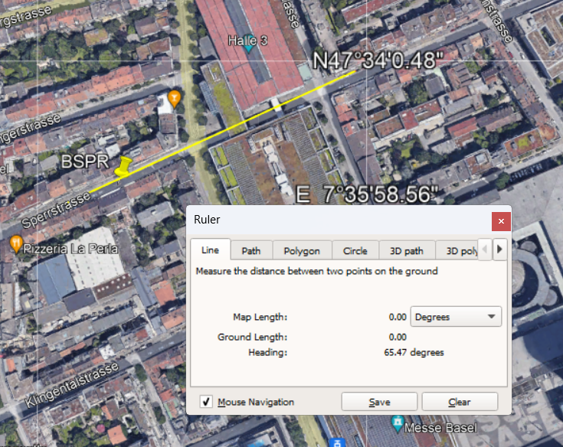

Building,  
 Ref Bldg Midrise Apartment Post1980_v1.3_5.0, !- Name  
 40.0000, !- North Axis {deg}

UMG:

theta_canyon,-20, # Canyon direction from geographical north,

# Sensor Height

# Ue2 (Basel-Spalenring, code in database: BSPA) Sensor height = 3m

Maximum Daily UHI effect: 5.2 K

VCWGv2.0.0 (Monthly) MeanBiasError: -0.53(K), RMSE: 0.56(K), R2: 0.98(-)

UWG Monthly MBE: -0.6(K), RMSE: 0.9(K)

NMBE(%), CV-RMSE(%), R2(-)

('VCWG-Potential Temperature error', 9.48, 13.52, 0.7)

('VCWG-Real Temperature error', 9.05, 13.11, 0.72)

('VCWG(idf-Refining)-Potential Temperature error', 7.91, 10.88, 0.8)

('VCWG(idf-Refining)-Real Temperature error', 7.53, 10.5, 0.82)

